**Assignment 3**

**-**Tharini Mala SK

711119104069

1.Create a Bucket in IBM object storage.

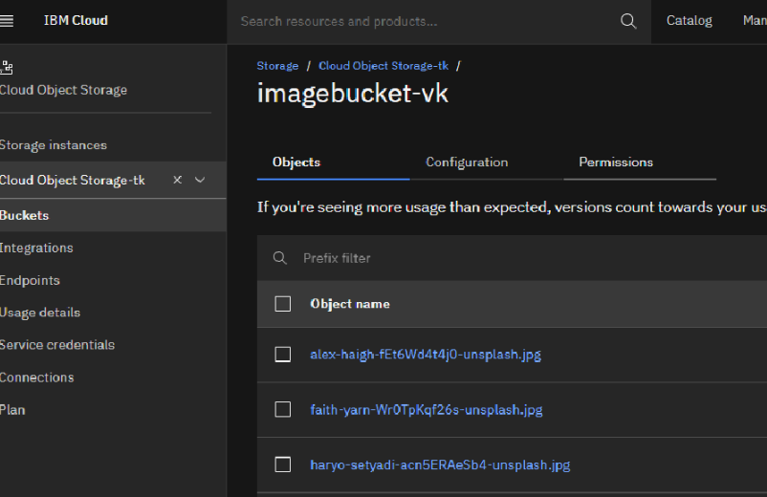

2.Upload an 5 images to ibm object storage and make it public. write html code to displaying all the 5 images.

Program:

|  |
| --- |
|  |
| <!DOCTYPE html> |
|  | <html lang="en"> |
|  | <head> |
|  | <title>Fashion Shop</title> |
|  | <meta charset="utf-8"> |
|  | <meta name="viewport" content="width=device-width, initial-scale=1"> |
|  | <link rel="stylesheet" href="<https://maxcdn.bootstrapcdn.com/bootstrap/3.4.1/css/bootstrap.min.css>"> |
|  | <script src="<https://ajax.googleapis.com/ajax/libs/jquery/3.6.0/jquery.min.js>"></script> |
|  | <script src="<https://maxcdn.bootstrapcdn.com/bootstrap/3.4.1/js/bootstrap.min.js>"></script> |
|  | <link rel="stylesheet" href="<https://cdnjs.cloudflare.com/ajax/libs/font-awesome/4.7.0/css/font-awesome.min.css>"> |
|  |  |
|  | <style> |
|  | body{ |
|  | background-color:#FAEBD7; |
|  | display:flex; |
|  | } |
|  |  |
|  | .card { |
|  | box-shadow: 0 4px 8px 0 rgba(0,0,0,0.2); |
|  | transition: 0.3s; |
|  | width: 80%; |
|  | border-radius:10px; |
|  |  |
|  | } |
|  |  |
|  | .card:hover { |
|  | box-shadow: 0 8px 16px 0 rgba(0,0,0,0.2); |
|  | } |
|  |  |
|  | .text { |
|  | padding: 5px 16px; |
|  | } |
|  |  |
|  | .checked { |
|  | color: orange; |
|  | } |
|  | </style> |
|  |  |
|  |  |
|  |  |
|  | </head> |
|  | <body> |
|  | <div class="container"> |
|  |  |
|  | <h1 align="center"><b>Welcome to Fashion Store</b></h1> |
|  | <br> |
|  | <div class="row"> |
|  | <div class="col-sm-12 col-md-6"> |
|  | <p> <div class="card" > |
|  | <img src="kidsdesigner.jpg" alt="Girls" style="width:100%" class="img-responsive"> |
|  | <div class="text"> |
|  | <h4><b>Silk and Net Party Wear</b></h4> |
|  | <span class="fa fa-star checked"></span> |
|  | <span class="fa fa-star checked"></span> |
|  | <span class="fa fa-star checked"></span> |
|  | <span class="fa fa-star checked"></span> |
|  | <span class="fa fa-star"></span> |
|  | </div> |
|  | </div></p> |
|  | </div> |
|  | <div class="col-sm-12 col-md-6"> |
|  | <p><div class="card" > |
|  | <img src="girlspartywear.jpg" alt="Girls" style="width:100%" class="img-responsive"> |
|  | <div class="text"> |
|  | <h4><b>Net Blue Girls Party Wear</b></h4> |
|  | <span class="fa fa-star checked"></span> |
|  | <span class="fa fa-star checked"></span> |
|  | <span class="fa fa-star checked"></span> |
|  | <span class="fa fa-star checked"></span> |
|  | <span class="fa fa-star"></span> |
|  | </div> |
|  | </div></p> |
|  | </div> |
|  |  |
|  |  |
|  | </div> |
|  |  |
|  |  |
|  | <p style="padding-top:20px;"> |
|  | <div class="row"> |
|  | <div class="col-sm-12 col-md-6"> |
|  | <p><div class="card" > |
|  | <img src="kidsgirlsparty.jpg" alt="Girls" class="img-responsive"> |
|  | <div class="text"> |
|  | <h4><b>Silk and Net Party Wear</b></h4> |
|  | <span class="fa fa-star checked"></span> |
|  | <span class="fa fa-star checked"></span> |
|  | <span class="fa fa-star checked"></span> |
|  | <span class="fa fa-star "></span> |
|  | <span class="fa fa-star"></span> |
|  | </div> |
|  | </div></p> |
|  | </div> |
|  | <div class="col-sm-12 col-md-6"> |
|  | <p><div class="card" > |
|  | <img src="kidsmodalgown.jpg" alt="Girls" class="img-responsive"> |
|  | <div class="text"> |
|  | <h4><b>Net Blue Girls Party Wear</b></h4> |
|  | <span class="fa fa-star checked"></span> |
|  | <span class="fa fa-star checked"></span> |
|  | <span class="fa fa-star "></span> |
|  | <span class="fa fa-star "></span> |
|  | <span class="fa fa-star"></span> |
|  | </div> |
|  | </div></p> |
|  | </div> |
|  |  |
|  |  |
|  | </div> |
|  |  |
|  | </p> |
|  |  |
|  | <p style="padding-top:20px;"> |
|  | <div class="row"> |
|  | <div class="col-sm-12 col-md-6"> |
|  | <p><div class="card" > |
|  | <img src="chiffonpartywear.jpg" alt="Girls" class="img-responsive"> |
|  | <div class="text"> |
|  | <h4><b>Chiffon Party Wear Gown</b></h4> |
|  | <span class="fa fa-star checked"></span> |
|  | <span class="fa fa-star checked"></span> |
|  | <span class="fa fa-star checked"></span> |
|  | <span class="fa fa-star"></span> |
|  | <span class="fa fa-star"></span> |
|  | </div> |
|  | </div></p> |
|  | </div> |
|  | <div class="col-sm-12 col-md-6"> |
|  | <p><div class="card" > |
|  | <img src="kidgown.jpg" alt="Girls" class="img-responsive"> |
|  | <div class="text"> |
|  | <h4><b>Blue Party Wear Gown</b></h4> |
|  | <span class="fa fa-star checked"></span> |
|  | <span class="fa fa-star checked"></span> |
|  | <span class="fa fa-star checked"></span> |
|  | <span class="fa fa-star checked"></span> |
|  | <span class="fa fa-star"></span> |
|  | </div> |
|  | </div></p> |
|  | </div> |
|  |  |
|  |  |
|  | </div> |
|  |  |
|  | </p> |
|  |  |
|  |  |
|  |  |
|  | </div> |
|  | </body> |
|  | </html> |
|  |  |

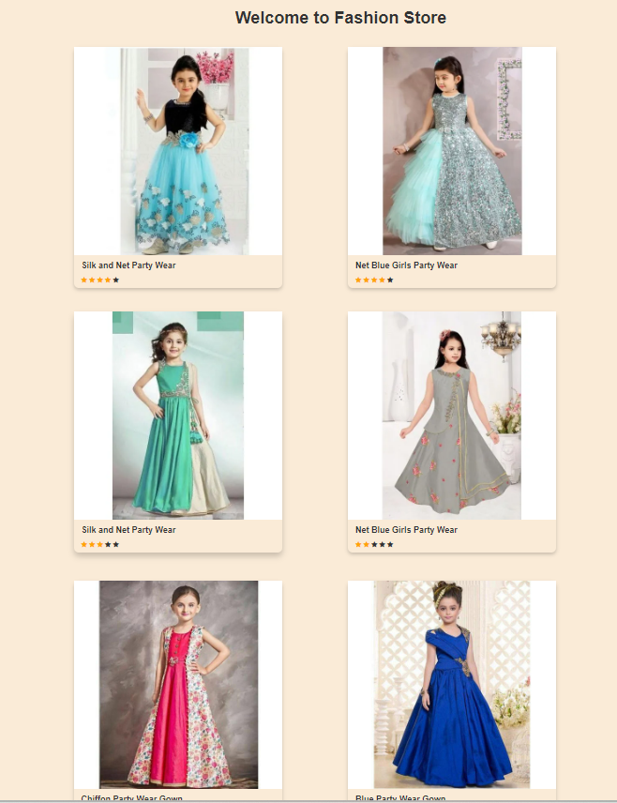

3.Upload a css page to the object storage and use the same page in your HTML code.

<style>

 body{

 background-color:#FAEBD7;

 display:flex;

}

 .card {

  box-shadow: 0 4px 8px 0 rgba(0,0,0,0.2);

  transition: 0.3s;

  width: 80%;

  border-radius:10px;

}

.card:hover {

  box-shadow: 0 8px 16px 0 rgba(0,0,0,0.2);

}

.text {

  padding: 5px 16px;

}

.checked {

  color: orange;

}

  </style>

4.Design a chatbot using IBM Watson assistant for hospital. Ex: User comes with query to know the branches for that hospital in your city. Submit the web URL of that chat bot as a assignment.

URL for Chatbot assistant: <https://web-chat.global.assistant.watson.appdomain.cloud/preview.html?backgroundImageURL=https%3A%2F%2Fau-syd.assistant.watson.cloud.ibm.com%2Fpublic%2Fimages%2Fupx-3522e51f-548b-4c88-9496-9b1500d30471%3A%3A776321a7-0711-42d0-a262-6d9b654527b6&integrationID=47fd72a8-89fb-42e5-942b-340e3e98e386&region=au-syd&serviceInstanceID=3522e51f-548b-4c88-9496-9b1500d30471>

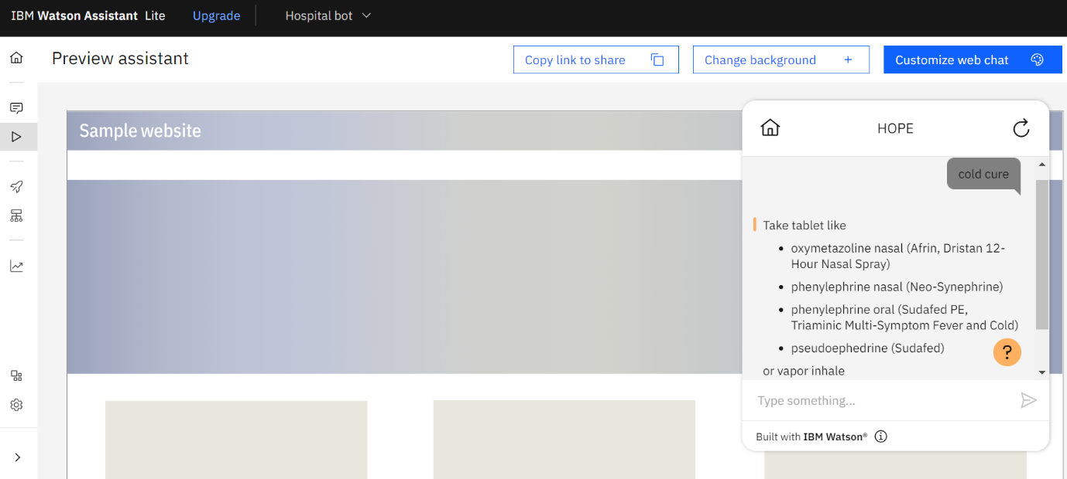

5.Create Watson assistant service with 10 steps and use 3 conditions in it. Load that script in HTML page.

